Name:A V S N R Akhila
roll no:2520030022
sec-01
Week1-skill
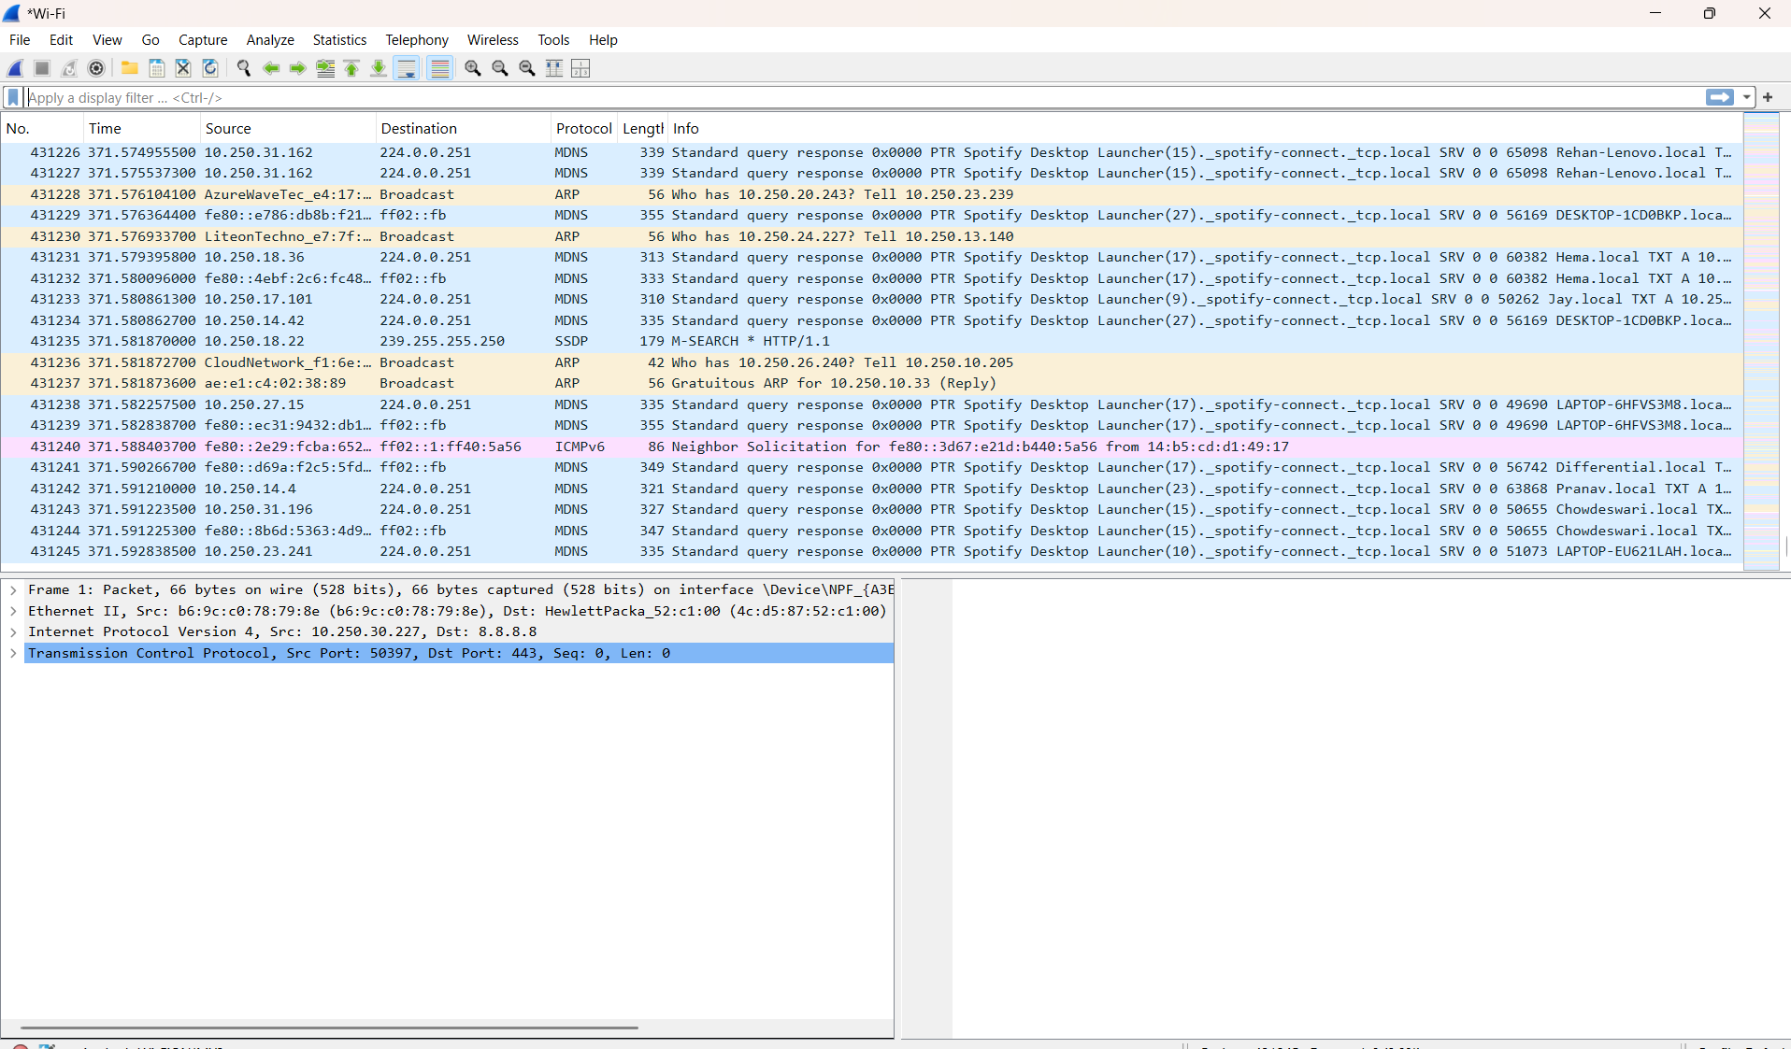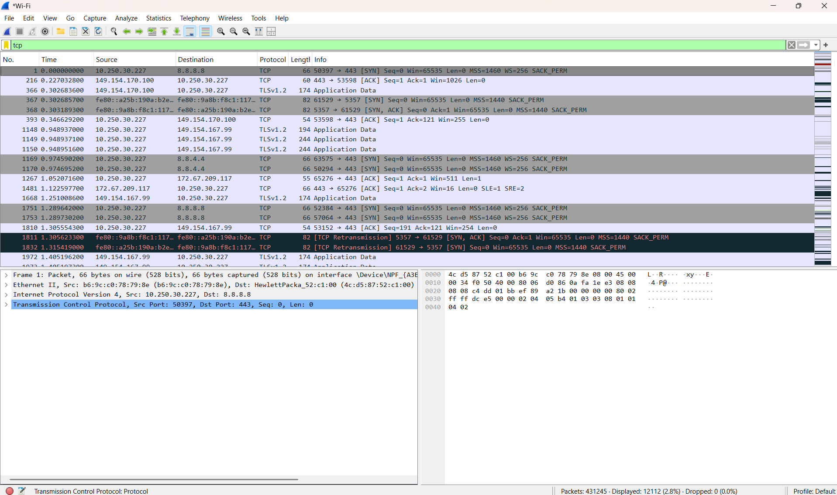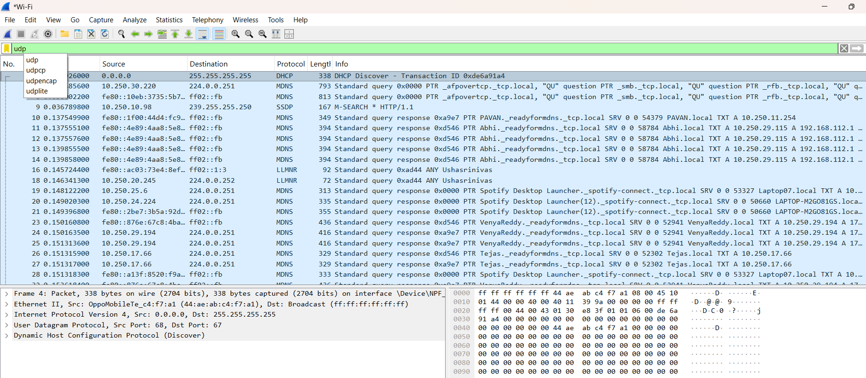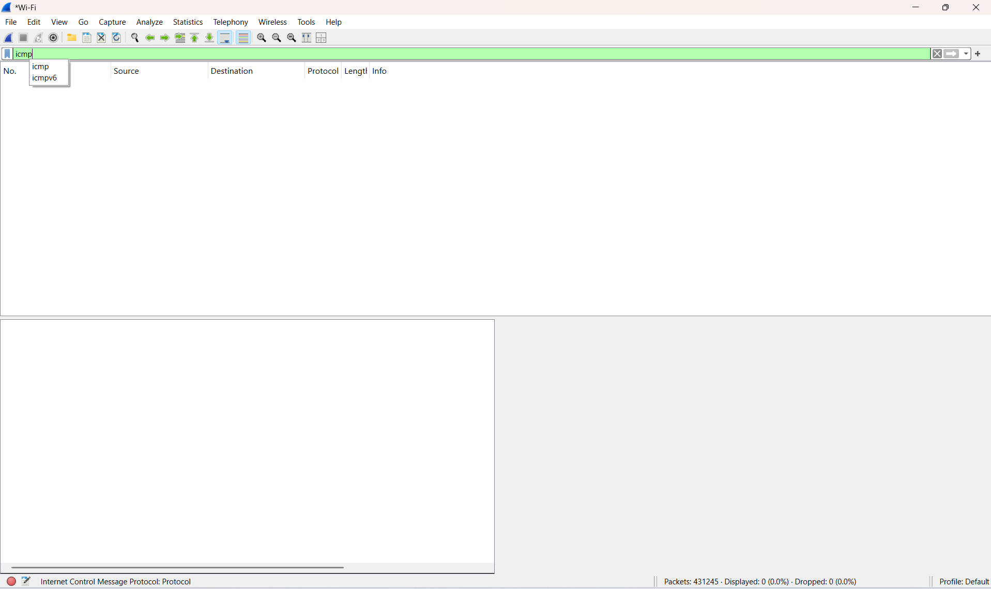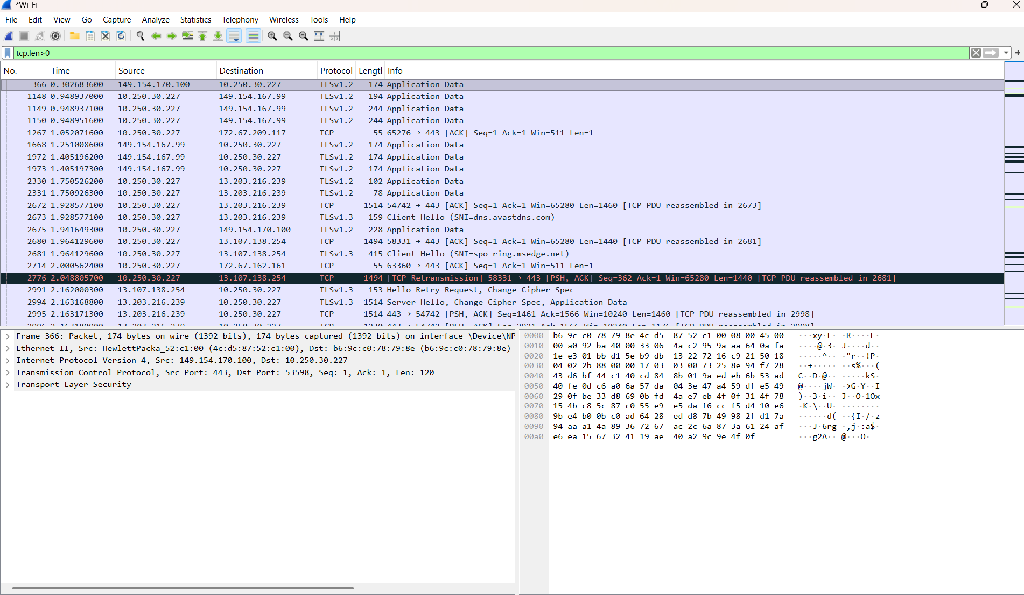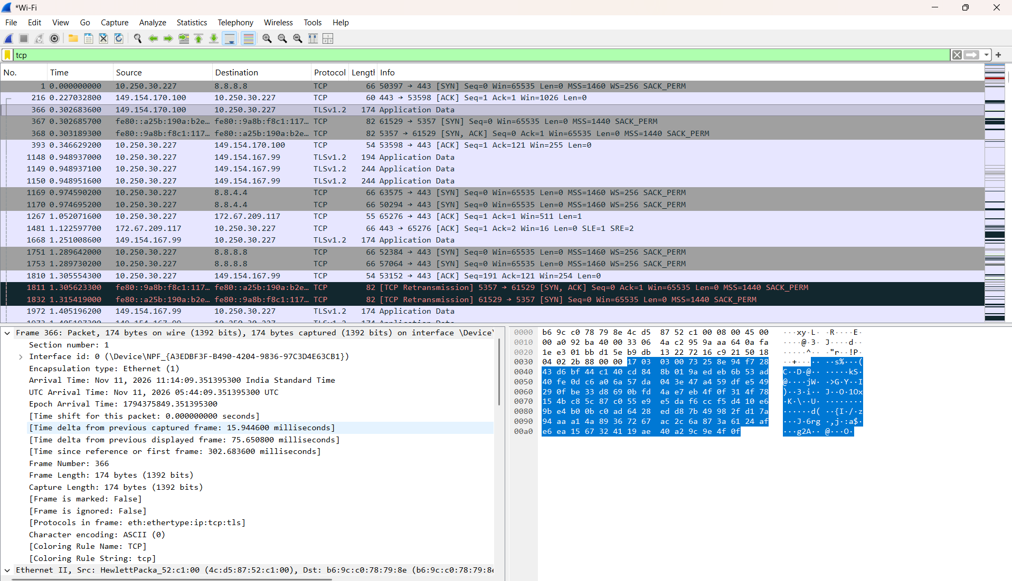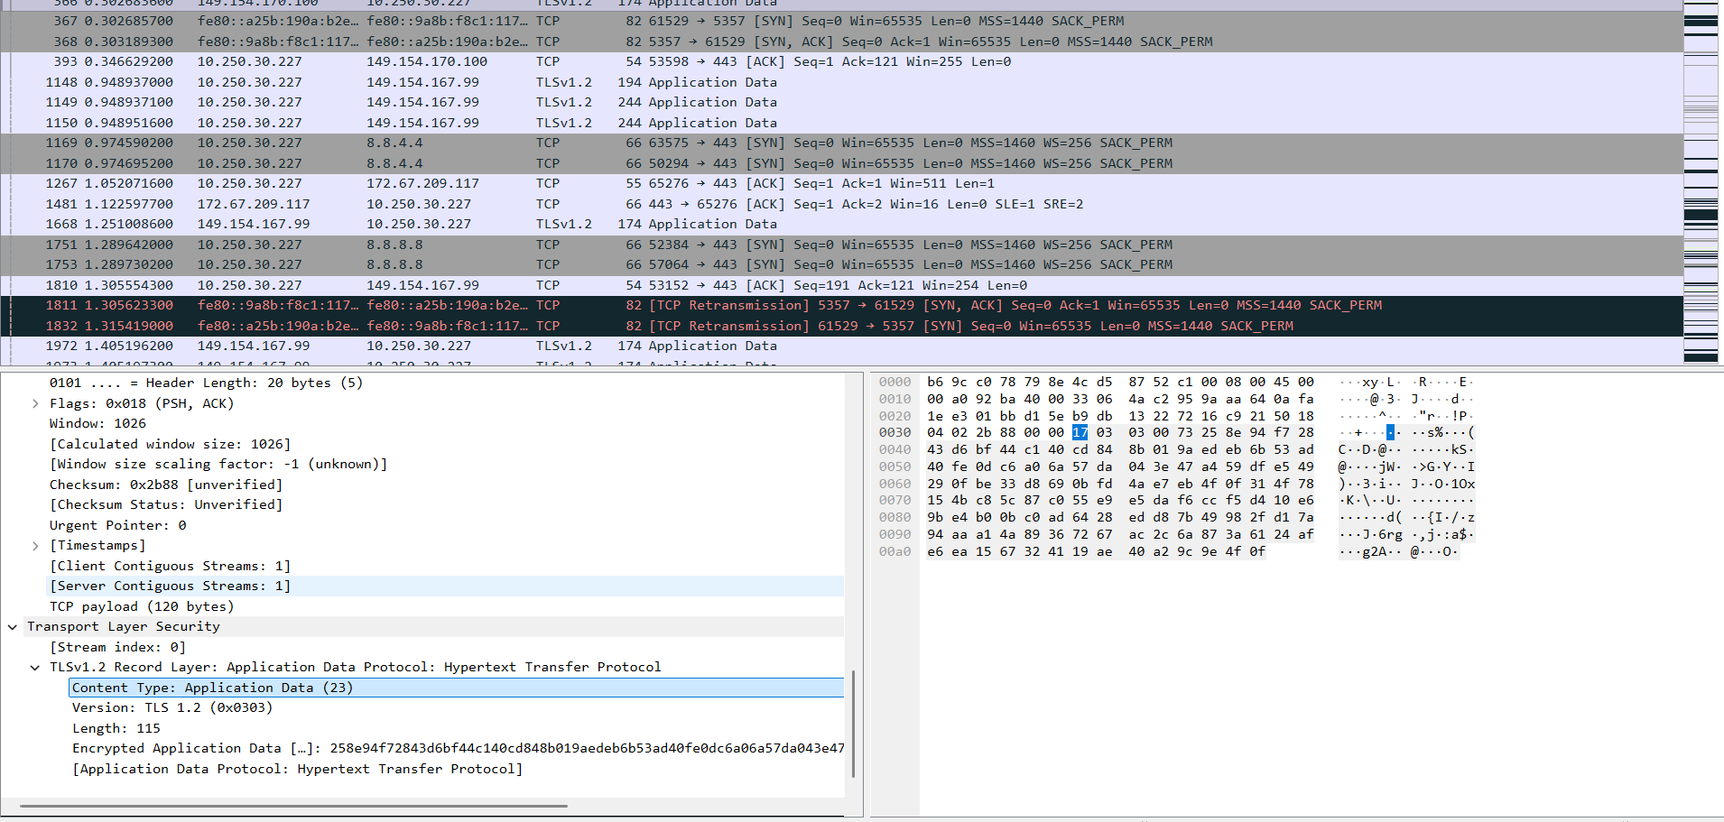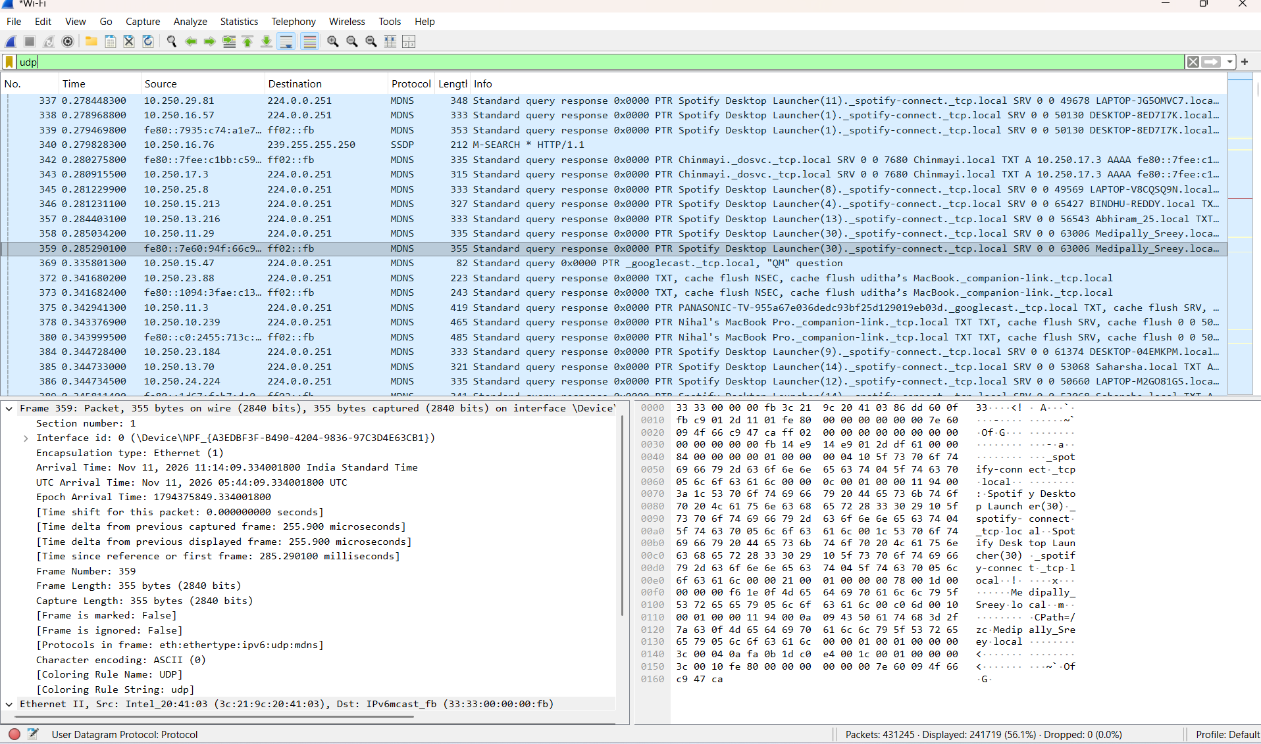

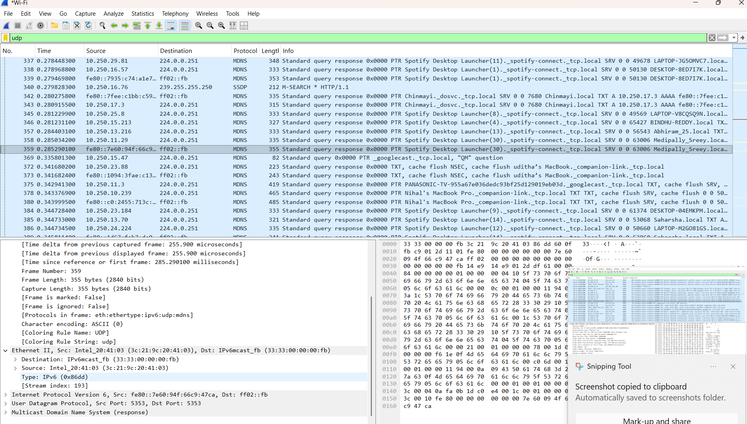

Calculations:
1. TCP Packet Calculations
Given:
- Frame Length = 178 bytes
- Ethernet Header = 14 bytes
- IPv4 Header = 20 bytes
- TCP Header = 20 bytes
- TCP Payload = 124 bytes
A. Total Header Overhead
A. Total Header Overhead
14 + 20 + 20 = 54 bytes
B. Total Packet Size
54 + 124 = 178 bytes
C. Payload Efficiency
(124 / 178) × 100 = 69.66%
D. Header Overhead Percentage
(54 / 178) × 100 = 30.34%
2. UDP Packet Calculations
Given:
- Frame Length = 182 bytes
- Ethernet Header = 14 bytes
- IPv4 Header = 20 bytes
- UDP Header = 8 bytes
- UDP Payload = 140 bytes
- A. Total Header Overhead
- 14 + 20 + 8 = 42 bytes
- B. Total Packet Size
- 42 + 140 = 182 bytes
- C. Payload Efficiency
- (140 / 182) × 100 = 76.92%
- D. Header Overhead Percentage
- (42 / 182) × 100 = 23.08%
3. Final Comparison Table
Parameter | TCP | UDP
Frame Length | 178 B | 182 B
Header Overhead | 54 B | 42 B
Payload Length | 124 B | 140 B
Payload Efficiency | 69.66% | 76.92%
Header Overhead % | 30.34% | 23.08%

